CMPS 312 Mobile App Development

**Assessment # 1**

|  |  |
| --- | --- |
| **Student Name** | Rashid Al-Bader |
| **Student Id** | 202008444 |
| **Email** | Ra2008444@qu.edu.qa |

**Grading Rubric - - In the *Functionality* column please specify either: *Working (completed x%)*, *Not Working (completed x%)* or *Not done*.**

|  |  |  |  |  |
| --- | --- | --- | --- | --- |
| Criteria | % | Functionality* | Quality of the implementation | Score |
| * Implemented the Product List Screen with the ability to the Search , Filter and add to cart | 50 | Working 100% | When adding to cart should appear small message that the item is add to the cart screen | 50% |
| * Implemented the Cart Screen with the ability to delete cart item | 30 | Working 100% |  | 30% |
| * Implemented the HomeScreen With the ability to toggle between screens | 20 | Working 100% |  | 20% |
| Total | 100 |  |  | 100% |
| Copying and/or plagiarism or not being able to explain or answer questions about the implementation | -100 |  |  |  |

**Possible grading for functionality**:

* ***Complete and Working*** (get 70% of the assigned grade),
* ***Complete and Not working*** (lose 40% of assigned grade)
* ***Not done*** get 0.
* The remaining grade is assigned to the quality of the implementation.
* Must submit screenshots in this **Testing-GradingSheet.docx** (otherwise - 10pts).

1. **Q1 output**

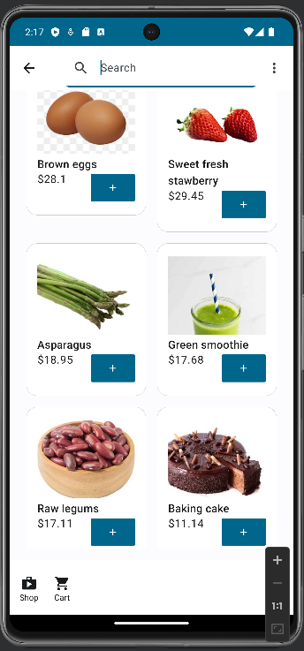

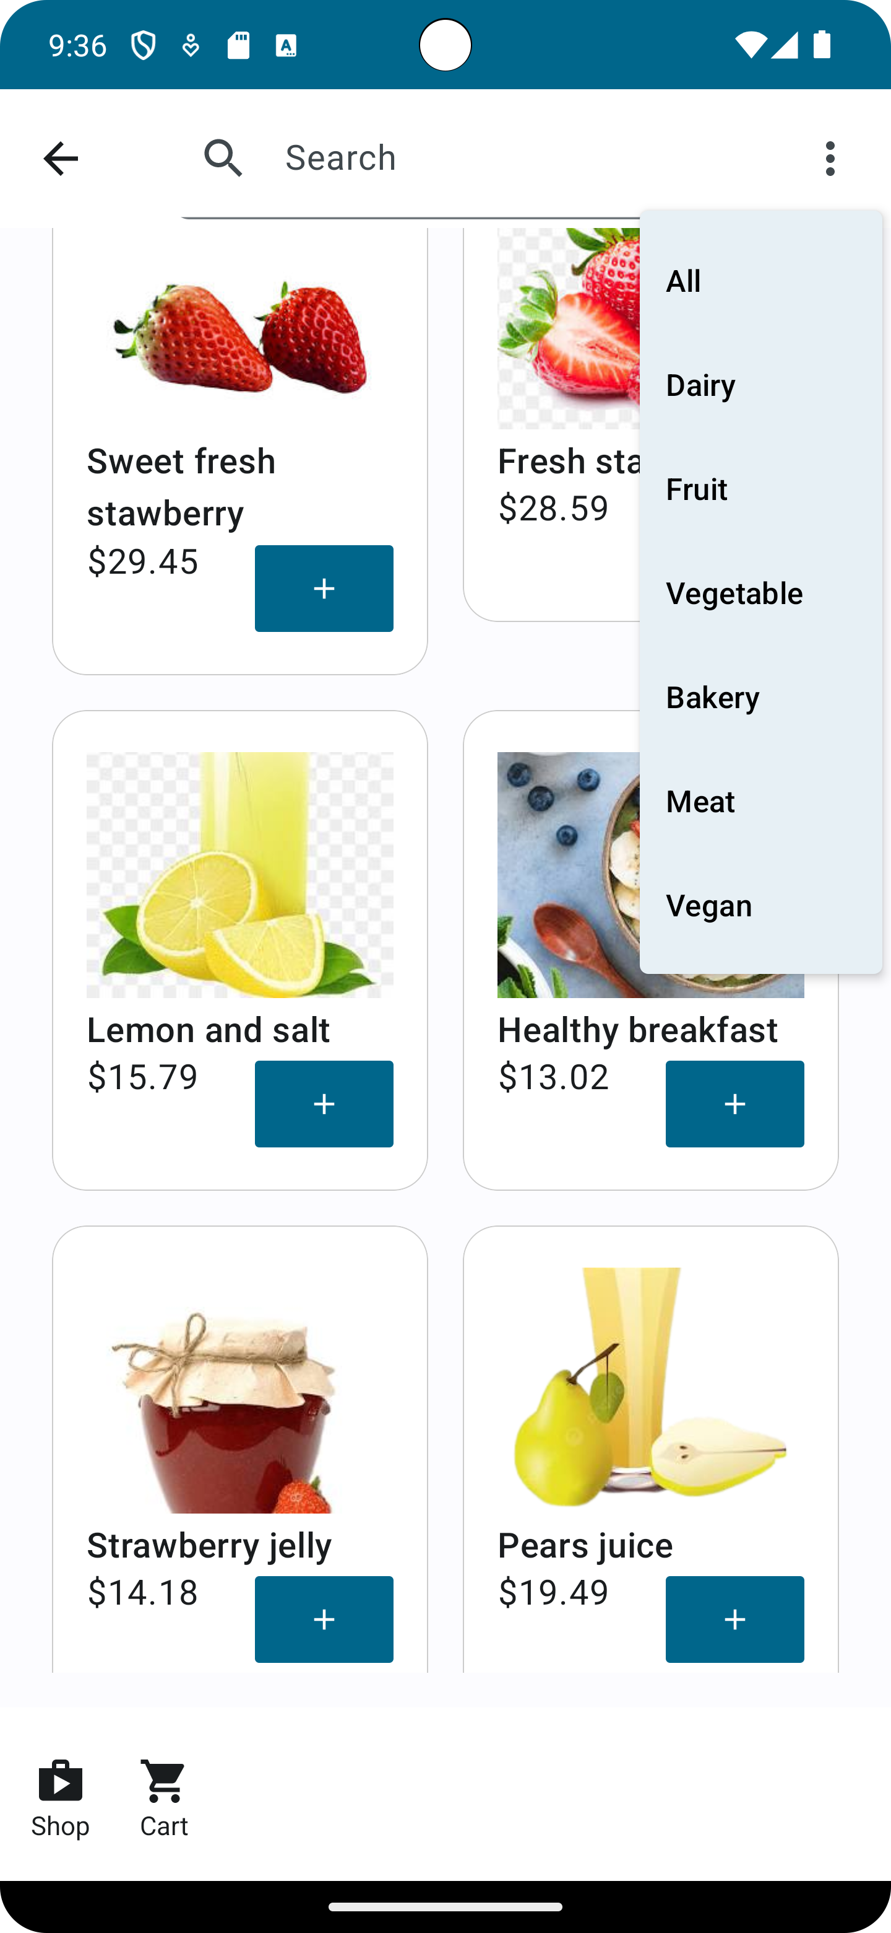

1. **Q2 output**

